**Programming Fundamentals Lab 06**

**Rana Muhammad Hussain**

**25K-0141**

**Screenshot of Task 1:**

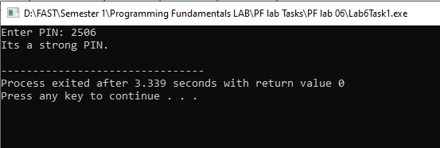

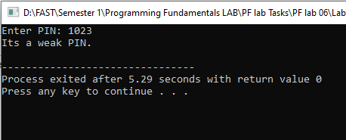

**Screenshot of Task 2:**

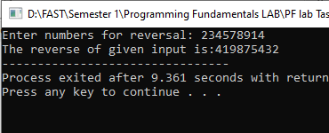

**Screenshot of Task 3:**

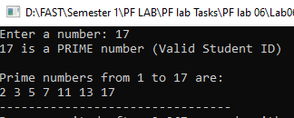

**Screenshot of Task 4:**

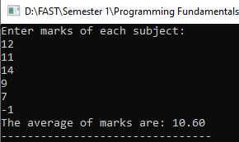

**Screenshot of Task 5:**

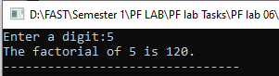

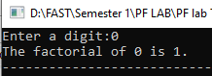

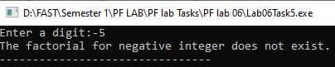

**Screenshot of Task 6:**

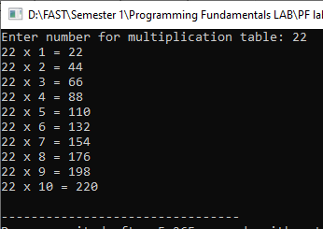

**Screenshot of Task 7:**

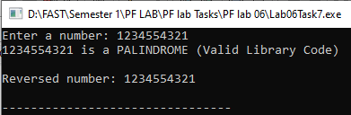

**Screenshot of Task 8:**

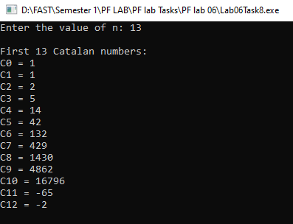

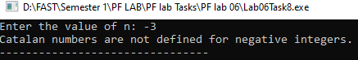

**Screenshot of Task 9:**

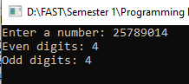

**Screenshot of Task 10:**

